The tool used to validate the code is BP-Cryptographic calculator produced by EFT Labs, market leader in simulators and testing tools. It could be downloaded from the company website for free.

The below screenshots validate the results of the code:

1. Generation of session key from Master Key and ATC

Master key value used is: 0123456789ABCDEF0123456789ABCDEF

ATC value used is: 00B4

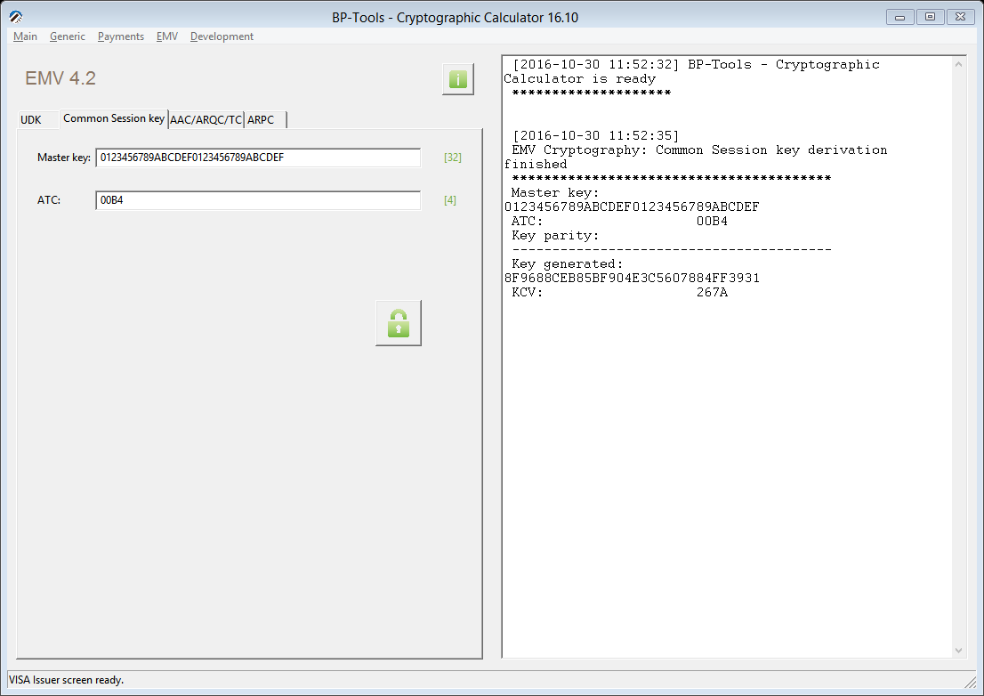

1. Generation of ARQC using session key created in the previous step an transaction data

Transaction data used:

0000000010000000000000000710000000000007101302050030901B6A3C00005503A4A082

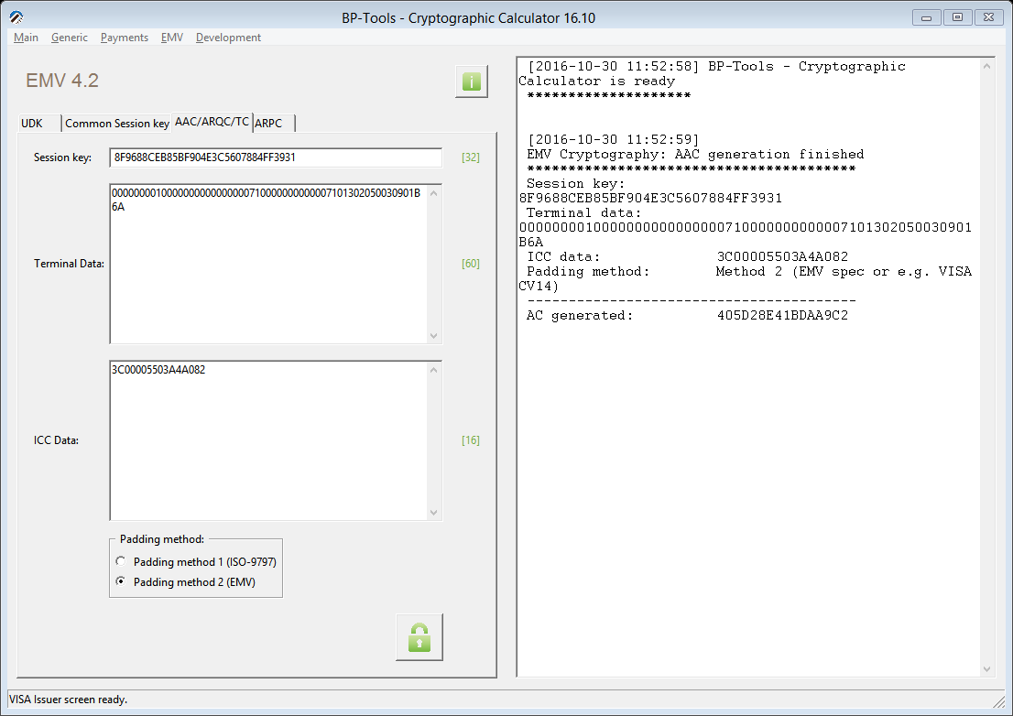

1. Generation of ARPC from the ARQC, ARC and session key

